**Experiment-7**

**LCD interface**

**Circuit Diagram**

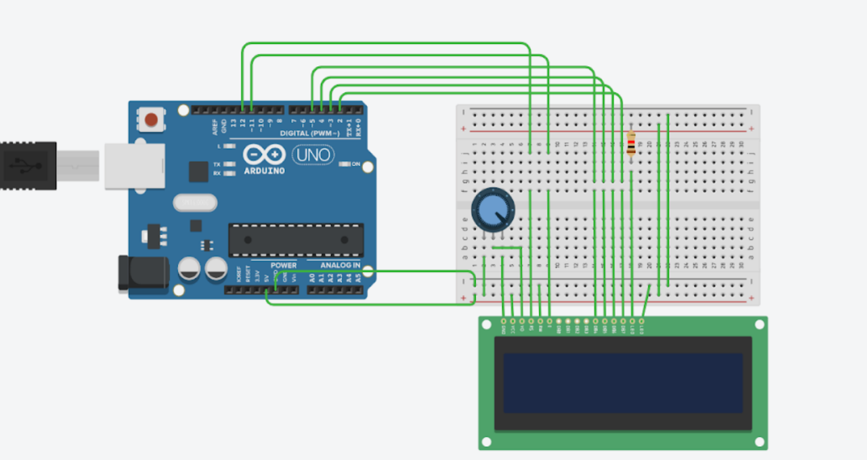

**Theory:**

**Concept Used:**

The concepts used for realization and implementation of the task are:

-Concept of Lcd(liquid crystal display)

-RS pin controls where in the lcd’s memory you are writing data to.

-R/W pin that selects reading or writing mode.

-enable pin that enable writing

-power supply and ground(GND) pins.

-8 Data pins starting from D0 to D7.

-Potentiometer for variable resistance.

**Learning and Observation:**

**Learning:**

One can easily interface a liquid crystal display with an Arduino to provide a user interface. LCD are commonly used to display data in devices like calculators, ovens and other electronic devices.

**Observations:**

I observed the functioning of the connected lcd display after the code was uploaded.

**Problems and Troubleshooting:**

* The circuit was not getting closed because some wires used were short and not at place so I tried to change the position.
* The Arduino board was not working because of short wire and port being far from where the hardware was kept so had to change some positions in order to get it worked.
* I had some issues with code initially so had to change my coding many times and I also forgot to choose port and tools option.

**Precautions:**

The precautions that we need to keep in mind while performing this experiment are

* The wires used should be inserted properly in the breadboard for the hardware to work properly. In this experiment proper insertion of wires is compulsory since if any of the single wire is loosen the whole circuit won’t work.
* We should take care that the circuit is closed .

**Learning Outcomes:**

* I have gained about certain projects and circuits using Arduino board and breadboard.
* I have got to know about LCD display concept.